**Seeing Diamonds: 1 and 2d Statistical Graphics in the Introductory Course**

David Kahle

Baylor University

**Key Words:** Data visualization, big data, introductory statistics

**Abstract**

Data visualization and exploratory data analysis are prime places in which individuals of all walks of life encounter statistics on a daily basis. This is especially true with the advent of “big data”, where complex relationships are the norm and out-of-the-box elementary statistical procedures must be applied with great care. These realizations rightly call us, as statistics educators, to redouble our efforts in teaching these most basic statistical methodologies in the introductory course. In this article I illustrate how Wickham’s diamonds dataset can be used to communicate a wide variety of statistical concepts and graphics in the introductory course.

**1. Introduction**

*The most important maxim for data analysis to heed, and one which many statisticians seem to have shunned, is this: “Far better an approximate answer to the* ***right*** *question, which is often vague, than an* ***exact*** *answer to the wrong question, which can always be made precise.”*

John Tukey (Tukey 1961, p.13)

*Modern data graphics can do much more than simply substitute for small statistical tables. At their best,* ***graphics are instruments for reasoning*** *about quantitative information. Often the most effective way to describe, explore, and summarize a set of numbers­–even a very large set–is to look at pictures of those numbers.*

Ed Tufte (Tufte 2001, p.8)

Emphasis added.

Being fluent in data visualization techniques is one of the key components to being a practicing statistician (read: data analyst). It is for this reason that data visualization is referred to several times in the American Statistical Association’s “Guidelines for Assessment and Instruction in Statistics Education: College Report” (GAISE) (Aliaga et al. 2005). The fact that data visualization plays a key role in each of GAISE’s six recommendations both reaffirms the importance of statistical graphics, even as early as the introductory course, and serves as a reminder to both student and instructor that statistics is not a mere collection of formulas and procedures, but rather a means of quantitative reasoning under uncertainty that is part art, part science.

GAISE’s recommendations include both the consumption and construction of statistical graphics. In short: we want students to be able to understand and critically assess statistical graphics when they are presented and, to some extent, to be able to create them themselves. Teaching students these skills is not a trivial task, particularly due to the time constraints typically allotted to data visualization in the introductory course. Nevertheless, I believe they are possible, to a reasonable extent.

In this article I illustrate how I introduce statistical graphics to my own introductory statistics course–by example. The introduction focuses on a single remarkable real-world dataset, which I call Wickham’s diamonds, to get the job done. Described in detail in the next section, the dataset comes as part of the **ggplot2** package in R (Wickham 2009). It is accessible via the following code in R:

R> install.packages(“ggplot2”)

R> library(ggplot2)

R> diamonds

Additionally, the dataset can be downloaded from <http://bit.ly/1A0t1wT>. The code used to generate the graphics in this article can be found at <INSERT GITHUB README PAGE HERE>; it is predominantly R code, but some Wolfram (Mathematica) was used as well. While there are many resources to look to should you want use R in your introductory statistics course (Pruim et al. 2014 and the associated <http://mosaic-web.org> come to mind), command-line programming is not necessary. Most of the graphics created in this work can be created by standard statistics software, for example JMP’s Graph Builder application.

Since data visualization is an incredibly large field and time is precious in the introductory course, I generally limit my discussion to the visualization of the distributions of data; that is what is presented here. While this eliminates topics such as line charts used in (e.g.) time series analyses and choropleth maps used in (e.g.) epidemiology, it has the advantage of circumscribing the discussion in important ways: the graphics discussed correspond directly to the description of data in the intro course (see Section 2); they can be built up from basic visuals familiar to students (e.g. bar charts); and they tie in nicely with inferential procedures in the course such as ANOVA and chi-squared tests of homogeneity. I nevertheless think it is important to mention on-going research in the field such as interactive graphics and the computational challenges of big data.

Wickham’s diamonds dataset is a great dataset to use to introduce statistical graphics for several reasons. First, the dataset has variables of differing types (see Section 2), and therefore can be used to illustrate how statistical graphics must change based on type. Second, virtually all students have some familiarity with diamonds, at very least the basics: their size is measured in carats; they become more expensive as they get larger; there are standard rating criteria (the “four C’s”); and so on. This knowledge leads to interesting questions that can be explored with a wide range of graphics. Third, the dataset is fairly large. At over fifty thousand diamonds, raw-data graphics easily show pronounced overplotting effects, which can be used to motivate ideas such as jittering and binning/summarizing. Lastly, in my experience the topic of diamonds resonates with both male and female college students (my unscientific explanation: the girls tend to be culturally inclined towards diamonds, and the guys similarly inclined to think they will one day have to buy one).

An additional note is warranted. Almost every introductory text I own teaches stem-and-leaf diagrams, including those that are based on GAISE. It is my strong belief that we have to stop teaching them as part of the data visualization component of the introductory course, and for at least four reasons. First, they are of interest primarily for historical reasons. While they were helpful in eras of exclusively text-based computer interfaces, virtually every machine in modern use has the ability to create high quality graphics, even those with command-line only interfaces. Second, they aren’t used in modern research as they’ve been supplanted by proper graphics. Third, they don’t extend well to even moderately sized datasets, because they weren’t designed for them. Finally, stem-and-leaf diagrams are conceptual islands. The graphics presented in this work build on each other, creating more and more sophisticated graphics based on elementary ones like the bar chart and scatterplot. Stem-and-leaf plots, by contrast, lead nowhere, and therefore have very little practical pedagogical value. Thus, I urge other educators to migrate away from this method and toward those described below, which enjoy wide support in the statistical computing and graphics community.

**1.1 Relationship to Wickham 2009**

Some readers will notice that this article is similar to that of Wickham 2009. That already being an excellent text begs the question: what is the value of the present article?

There are many key differences between the two. First, that text is geared towards explaining software for statistical graphics to a computational audience and generally assumes knowledge of statistical graphics. Second, the content in that text concerning the diamonds dataset is dispersed over the whole 200+ page text, while here it is the sole focus throughout. Third, the present article includes a discussion on mosaic plots for visualizing the joint distribution of discrete data, which are used frequently in practice yet not discussed in that text because they are not implemented in **ggplot2**. Lastly, and most importantly, this article is focused on the diamonds dataset as it is helpful for teaching statistical graphics in the introductory course. I follow a simple, bottom-up approach to graphics centered on the visualization of distributions of data and include tips and suggestions I have found helpful in my own course; where I have found a topic too detailed for the intro course, I have eliminated it. For instance, the discussion in this article is limited to graphics for one and two variables at a time. Although in some ways unsatisfying, graphics to visualize the joint distribution of several variables require a larger discussion of aesthetics mappings and scales that is unrealistic in the intro course because it takes too much time. Thus, while this article and Wickham 2009 share many things in common, they differ in key ways germane to the present audience. That being said, I find Wickham 2009 to be an excellent resource and strongly recommend it to anyone wanting to go deeper with the material presented here.

**2. Wickham’s Diamonds Dataset**

In the introductory statistics course, the term “data” is typically limited to spreadsheet-type data whose rows, of which there are *n*, represent subject or objects and whose columns, of which there are *p*, represent variables or measurements on those subjects/objects. In this context, Wickham’s diamonds dataset consists of *p =* 10 measurements (variables) on *n =* 53,940 individual round-cut, unset diamonds that were collected observationally. To get a sense of the dataset, the first twenty such diamonds can be seen in Figure 1.

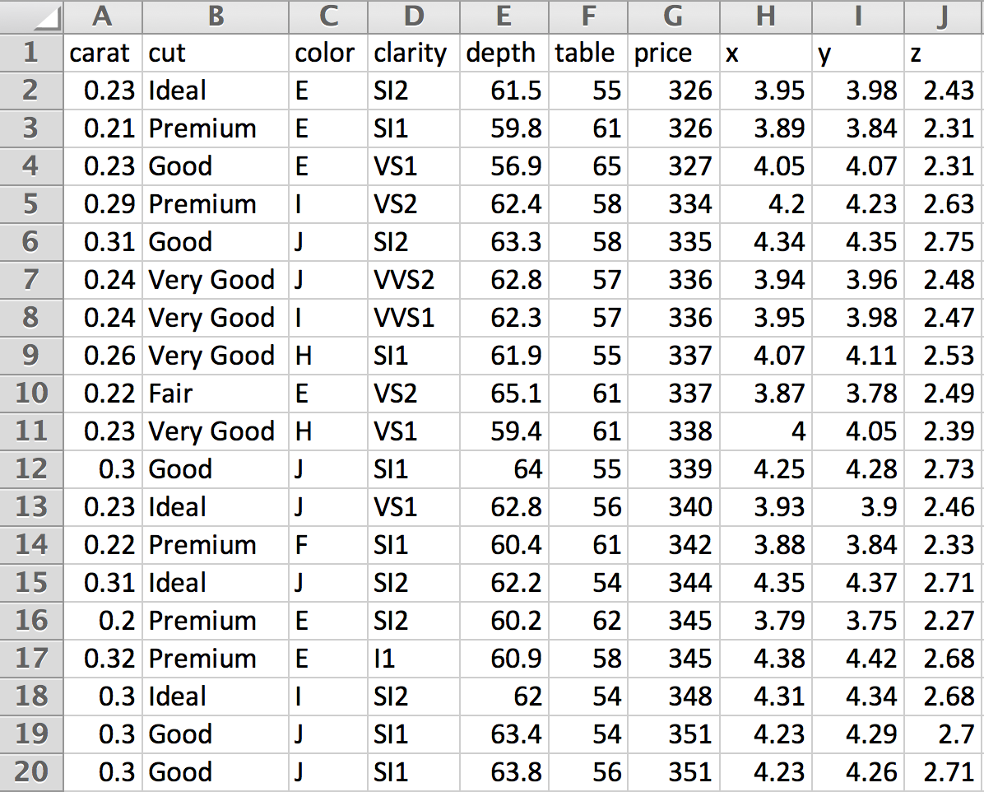

Figure . The first twenty rows of the diamonds dataset.

Below are details on each of the measurements. The scales of the diamonds are those of the Gemological Institute of America (GIA), which certifies diamonds for a cost. The GIA sets scales such as those used for color and clarity as well as other qualities not in the dataset, such as fluorescence. To keep the scale consistent, the diamonds are graded by comparison with master stones in controlled settings.

*Helpful Hint: Using the diamonds dataset can be a nice way to introduce variable types and scales. While not all variable types are present (there is no count variable, for example), topics such as ordinal variables and the continuous vs. discrete divide can be addressed with the dataset. To supplement for the missing ones, you may consider giving as examples the shape the diamond is cut into as a categorical variable (all those in the dataset are round) and the number of imperfections in the diamonds as a count (quantitative discrete) variable.*

*Alternative Application: The discrete/continuous distinction can sometimes be challenging for students. Without getting too technical, useful device to explain the divide is the following: if the sample space is finite or countably infinite, the experiment or variable is said to be discrete, if it is uncountably infinite, it is said to be continuous – this will help in explaining (for example) why the Poisson distribution is a discrete distribution even though its sample space is infinitely large. Of course, most students at the introductory level have no exposure to orders of infinity. To overcome this, and introduce students to some beautiful mathematics in the process, have them watch the seven minute TED-Ed talk given by Dennis Wildfogel as a homework assignment, available online at* [*https://www.youtube.com/watch?v=UPA3bwVVzGI*](https://www.youtube.com/watch?v=UPA3bwVVzGI)*. Most students find the talk fascinating, and it’s rewarding knowing that you’re educating students in ways outside of statistics as well. This is particularly true for educators at liberal arts institutions.*

carat. The size of diamonds is typically communicated in carats, the carat being a unit of mass equal to 200mg. In this exposition we often refer to “carat weight,” as is typical in discussions of gems.

cut. The sparkle of a diamond is due to the extent to which light, entering the top of the diamond, is refracted around inside the diamond and exits the top. The phenomenon where light exits the bottom of the diamond is known as leakage; leakage is considered a bad quality because it diminishes the light leaving the top of the diamond and, therefore, the sparkle of the diamond. The amount of leakage of a diamond depends on the angles at which the diamonds are cut. Jewelry companies often have patents on specific geometries with which their diamonds are to be cut: a certain number of facets meeting at precise angles. cut refers to the quality with which the diamond cutter was able to achieve those specifications. It is rated on the five point scale Fair, Good, Very Good, Premium, and Ideal.

color. When diamonds are found in nature they typically range from being white, which is no color at all, to a slightly yellowish tint. This is due to imperfections at the molecular level, where some of the carbon atoms of the crystal lattice have been substituted with other elements. At slight to moderate levels, this is considered unfavorable; however, diamonds with a strong hue to them, such as yellow, red, or blue, are much more rare, and consequently more valuable. They are termed “fancy diamonds.” There are no fancy diamonds in the diamonds dataset, so that all the diamonds in the dataset range from colorless to a shade of yellow. Unfortunately, the standard scale is quite confusing; it ranges from D to Z, with D through E being termed “colorless” and G through J “near colorless.”

*Interesting Sidenote: When asked, untrained observers likely won’t detect a yellowish hue until around J, where it will appear very faint against a white background. If the diamond is set in a yellow-gold band, however, it can be harder to detect.*

clarity. Perfect diamonds are clear; however, all natural diamonds (those formed through normal geological processes) exhibit imperfections, at least at the microscopic level. In fact, synthetic diamonds, which are much less expensive, can be detected by their lack of imperfections. These imperfections take various forms, but are typically either black specks, which are graphite, or bubbles – pockets of air. Unfortunately, the clarity scale is even more confusing than that of color. The best is Flawless, followed by Internally Flawless, Very Very Slightly Included with tiers of 1 (better) and 2, Very Slightly Included 1 and 2, Slightly Included 1 and 2, and Included 1, 2, and 3. The diamonds dataset contains no Flawless diamonds. The rest are abbreviated IF, VVS1, VVS2, VS1, VS2, SI1, SI2, and I1 (diamonds also contains no Included 2 or 3 diamonds).

x, y, z, table and depth. Diamond dimensions, in millimeters, are provided according to Figure 2. What delineates x from y in terms of physical dimensions is not clear, but as it is not relevant for any problems, it can be disregarded.

price. The assessed price of the diamond, in US dollars.

*Teaching Point: Is price a discrete or continuous variable? This actually gets away from the previously discussed technical details, as most statisticians would call this price variable continuous. Why? (Answer: Practically speaking, there are over 10,000 unique numerical price observations. Statistics is both an art and a science. The artistic component of statistics looks at the price data and says that, while it’s true that the sample space is finite, it’s quantitative and* large*; moreover, the differences of the outcomes are on the order of 1, which is very small compared to the dispersion of the data. Put another way, if we were to consider the units of price as thousands of dollars and then look at the raw numbers out of order, we would be hard-pressed to consider them as discrete as opposed to simply rounded continuous measurements.)*

Figure 2. Diamond variables x, y, z, table and depth.

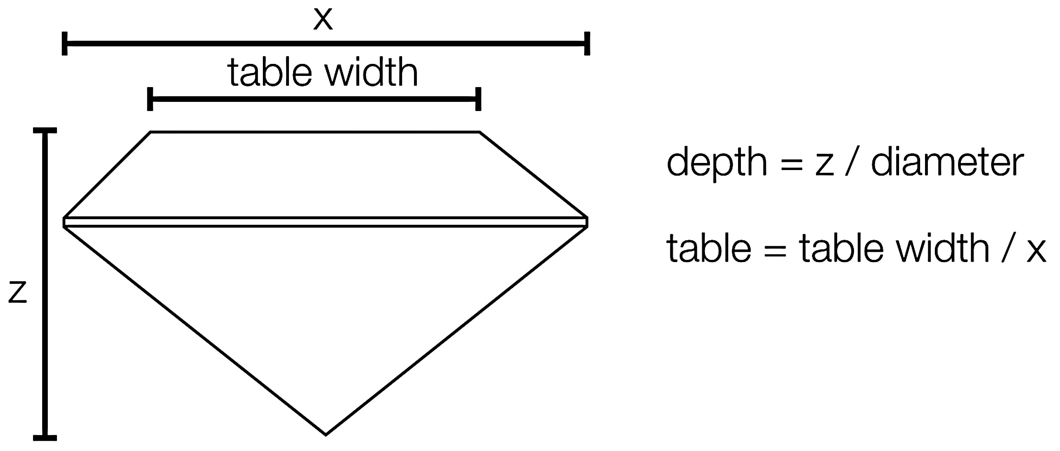

**2.1 Is Wickham’s diamonds “big data”?**

Although the term “big data” is currently in fashion, the term is notoriously difficult to precisely define; however, by virtually no current definition would the dataset be considered “big data.” This may come as a surprise to students, since printing out the Excel spreadsheet using 12 point font would require well over two reams of paper! However, at just under 3Mb in size (as a .csv), the dataset is easily held in memory and can be manipulated with any standard software.

*Potential Teaching Digression: One major current problem in statistics is the so-called p > n problem. For the diamonds dataset, clearly n >> p; however, now can be a nice place to introduce the p n problem. This is particularly true when teaching pre-health students where such problems are routinely encountered. Gene association problems provide an accessible example: the variables (columns) in question are gene expression levels, of which there may be tens or even hundreds of thousands, and the subjects (rows) represent individual patients.*

**3. Understanding the Variables Individually – 1d Graphics**

Every statistical analysis should begin with descriptive considerations of the data at hand, and, to the extent possible, visualization techniques should be included in these considerations (Tukey 1977). The comparatively more sophisticated inferential techniques learned later in the introductory course should only proceed *after* preliminary exploratory analyses, and for several reasons. First, if present, data contamination can lead to false conclusions. Visualizing data oftentimes brings these kinds of problems to light immediately.

*Teaching Tip: Early discussions of robustness in terms of numerical descriptives (particularly the sample mean and sample median) can pay huge dividends in understanding later in the course when explaining why the t-test can be corrupted by outliers.*

Second, violated assumptions can invalidate virtually any statistical procedure; many of these assumptions can be checked with graphics. Third, many problems don’t require inferential procedures because the conclusion is obvious from visualizing the data. Two-sample *t*-tests with palpable sample sizes and non-overlapping extents come to mind. The list of reasons to emphasize inferential procedures after descriptive ones goes on and on.

In this section we describe statistical graphics for a single variable. The topics discussed, although painfully simple at first, lay a foundation for more sophisticated graphics, so getting them down is absolutely essential.

*Common Pitfall: Students are almost always familiar with graphics for discrete variables, but don’t let them check out! Understanding exactly what is going on in discrete graphics is key to understanding continuous ones, such as the histogram, and then 2d graphics and beyond.*

**3.1 Discrete Variables**

Two of the most fundamental concepts in statistics are frequency distributions and relative frequency distributions. Given a discrete variable, the frequency distribution of the variable is simply the counts of the number of times each unique observation (level) was observed; the relative frequency distribution divides those numbers by the number of observations to provide the proportion of samples of a given level. The cut variable provides a good example as it has few levels.

|  |  |  |
| --- | --- | --- |
| **Cut level** | **Freq.** | **Rel. Freq.** |
| Fair | 1,610 | .030 = 3.0% |
| Good | 4,906 | .091 = 9.1% |
| Very Good | 12,082 | .224 = 22.4% |
| Premium | 13,791 | .256 = 25.6% |
| Ideal | 21,551 | .399 = 39.9% |

Table . Frequency and relative frequency distributions of cut.

The standard way to visualize these distributions is as bar charts or pie charts. For bar charts, we simply draw rectangles with base at the *x*-axis and whose height corresponds to the frequency of the level. Since the variable is ordinal, the order should be maintained in the graphic. For pie charts, a circle is drawn and wedges are depicted with angles equal to the relative frequencies times 360°. These can be seen in Figure 3.



**Figure 3.** Bar and pie charts for cut.

A few observations concerning bar and pie charts are helpful:

1. The use of the frequency distribution to construct the axis is arbitrary. Had we constructed the chart using relative frequency, the shape of the chart would look the same, only the *y*-axis scaling would be different and, of course, have a different interpretation.

*Teaching Tip: This fact is useful later on in the introductory course when introducing probability density functions, which use the density scaling. Scaling a histogram by density (so that the areas of the boxes sum to 1) has the same effect: the chart looks the same, but the axis is different.*

Note that some software, such as JMP, call “Frequency” “Count” and “Relative frequency” “Probability”; students should be aware of such dialects.

1. For a proper understanding of bar charts, the *x*-axis must be displayed at *y* = 0. Failure to do this can cause significant visual misrepresentation.
2. The width of the rectangles in the bar chart is arbitrary, as are the gaps between the bars. They should, however, remain equal in width as they do not represent something that varies between the levels.
3. Rotations of the pie chart do not change its interpretation.

In general, bar charts are vastly preferable to pie charts as human ability to perceive angles is poor compared to their ability to perceive positions, especially across distances, for instance with pie charts centered on cities on a map (Tufte 2001). Heymann and Le Grand (2013) and references therein are also helpful.

Considering the dataset at hand, it is interesting to note that Ideal cut diamonds are by a good margin the most prevalent type, and that Good and Fair diamonds are poorly represented.

**3.2 Continuous Variables**

There are several interesting continuous variables in the dataset to consider. We choose to investigate carat, the findings with price are similar.

**3.1.1 Scatterplots.** One of the most natural ways to visualize a collection of continuous measurements is simply to plot them on a real number line; this is referred to as a scatterplot or, more specifically, a 1d scatterplot. For clarity, in this example we select 50 such diamonds; which 50 is clear from the code. A typical scatterplot is then depicted in Figure 4.



Figure 4. One-dimensional scatterplot of 50 diamonds’ carat weights.

*Teaching Tip: Ask your students what might be bad about this graphic, and how to fix it.*

The chief problem with the scatterplot in Figure 4 is that points are stacked on top of each other, making the precise number of points ambiguous. This effect is known as *overplotting*; it is the visual confusion of a graphic due to plotting too much data. In this case “too much data” is simply 50 observations.

There are various ways to try to fix scatterplots to reduce the effect of overplotting. Three, in particular, are commonly employed.

1. *Jittering*. In Figure 4 the *y*-axis is not used, so it has no interpretation. One mechanism used to reduce overplotting is to generate random *y* values for the data, typically from a uniform distribution. An example of jittering is provided in Figure 5. Jittering can be a very effective way to reduce overplotting, but it has its limitations. Note that in Figure 5 the *y*-axis is meaningless.



Figure 5. Jittering in a 1d scatterplot.

1. *Alpha blending.* Another strategy is to make the individual points semi-transparent. Places where points coincide will then appear darker. An example of alpha blending is provided in Figure 6. Alpha blending is typically done in a manner that allows the statistician to know how many points need to stack to make the visual opaque. In Figure 6, this number is three.



**Figure 6.** Alpha blending and jittering in a 1d scatterplot (opaque = 3 points).

1. *Resizing.* Another common adjustment is to reduce the size of the points themselves. Like alpha blending, resizing can be very effective; however, the more one shrinks the points the harder the points are to see. Thus, resizing (and alpha blending for that matter) ought to be used judiciously – while they may help the overplotted regions, they hurt the more isolated regions. A final version of Figure 4 is presented in Figure 7.



Figure 7. Point resizing, alpha blending, and jittering in the 1d scatterplot.

Unfortunately, when all fifty thousand diamonds are plotted, not even the combination of the three adjustments can present us with a good graphic. Figure 8 depicts all 53,940 diamonds with an alpha blending that requires 100 points to achieve 100% opacity. However, the tradeoff becomes painfully apparent: while the overplotting persists in regions of extreme overplotting, the more isolated points grow practically invisible. Clearly an alternative strategy would be preferable.

*Teaching Tip: At this point, try having your students invent the histogram themselves. Pick out a few dozen diamonds, and ask them to construct a good visual. If they go by analogy the discrete data, they will make a frequency distribution and then a bar chart. But for most few-dozen datasets, this is very uninteresting – the frequency of each observation is 1 and the resulting bar chart is a bunch of useless spikes with height one. Use this to motivate the idea of binning.*

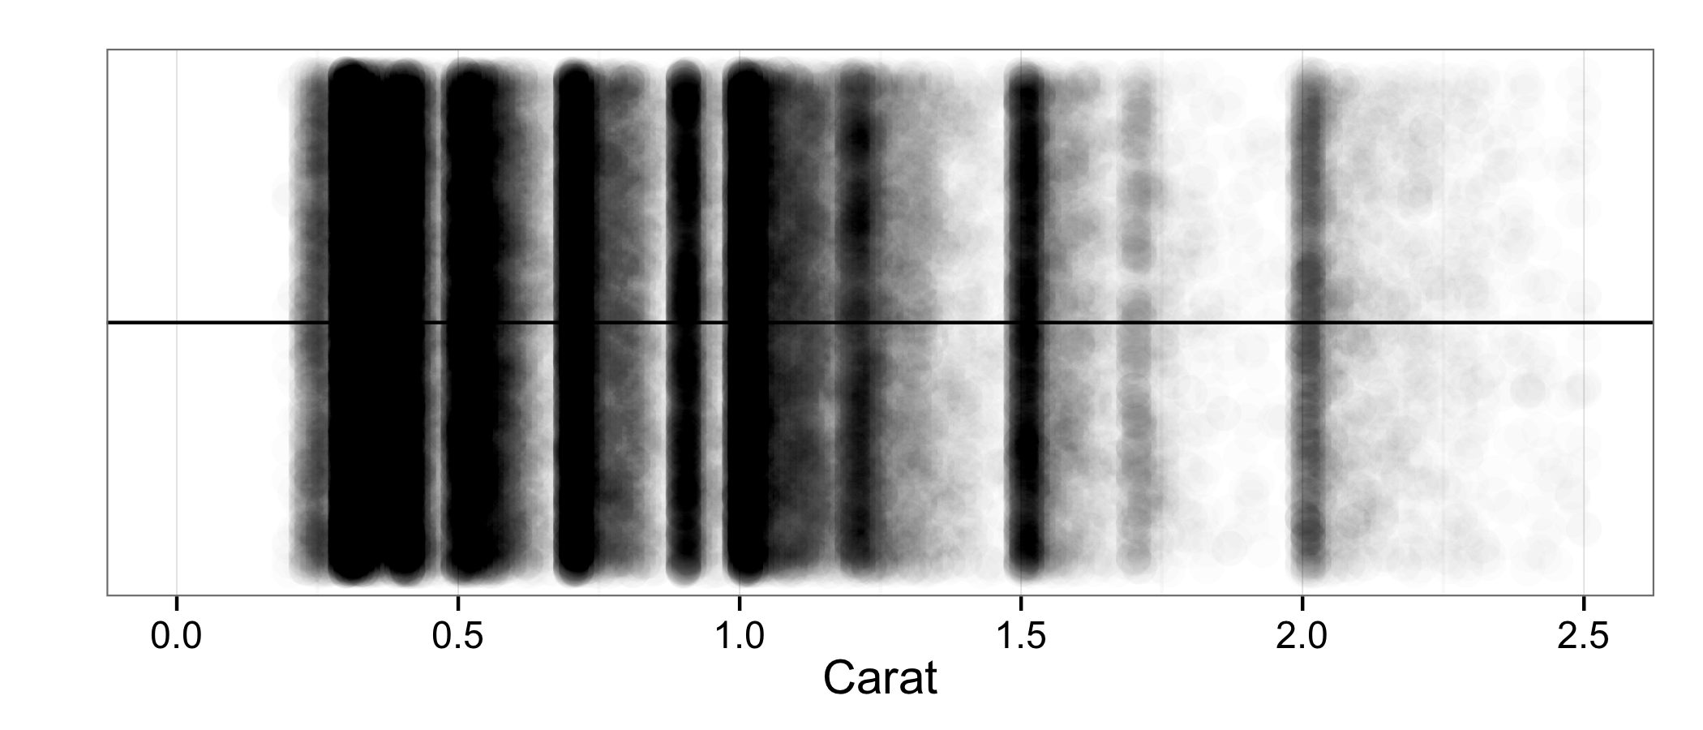

Figure 8. 1d scatterplot of all the diamonds' carat weights.

**3.1.2 Histograms.**

Moving away from scatterplots, a tempting idea is to turn to the idea that was successful with discrete data: construct a frequency distribution and then a bar chart based on the frequency distribution. However, that idea fails because with continuous data, the probability of ties is zero. Consequently, each observation will only be observed once, making the bar chart useless for practical purposes.

The idea of the histogram is to partition the range of the data into intervals called “bins,” count the number of observations falling into each bin, and use these frequencies to create a kind of bar chart. This bar chart, however, has rectangles whose widths and placement are meaningful.

The most important factor when constructing a histogram is the bin width used. If the width is too big, all the data clumps together in a small number of bins, which is never useful. If it is too small, then each bin will capture only a single observation, and you’re back in the bar chart situation. Histograms with bin widths 2, .17, and .01 are displayed in Figure 9.

Clearly the first histogram has bin widths that are too large, there is no shape to be seen. Glancing at the medium bin width (.17 carat) histogram, we see that it appears to be ok. For example, there are several bins that have substance to them. However, deeper considerations reveal that the medium bin width setting here is clearly not the best.

Understanding histograms is all about understanding structure, patterns in the peaks and valleys of the histogram. Structure can be present at various levels of resolution. While the medium-width histogram may capture some of the larger structural elements, a careful look at the third, small bin width (.01) histogram shows that the data is much more structured than one might think from looking at the middle histogram. Specifically, we see that there is in fact a great deal of structure: a repeating pattern of peaks followed by a trailing off. Why could this be?







Figure . Histograms of varying bin widths (top to bottom 2, .17, and .01).

When diamonds are harvested from the earth they are far from pristine products; they look somewhat like rock salt embedded in black rock. To make a presentable gem out of them, therefore, the black rock must be cut away and the diamond must be cut into a desired shape. Doing this requires sacrificing at least some of the diamond, so jewelers have developed very sophisticated techniques (computerized, even) to find, for a given rough diamond, the geometry that minimizes the loss of diamond and the orientation of that geometry in the stone. This maximizes the mass of the marketable diamond, and consequently its value. That is to say, when presented with a rough diamond, a jeweler has some flexibility in how she decides to cut it. Since the biggest determinant of a diamond’s cost is its mass (presumably), the cutter may be tempted to forgo angles ideal for minimizing leakage if in return they can produce a larger diamond.

Another effect is at play as well. The average price of the diamonds whose carat mass falls between .99 and 1.00 is $4,406, whereas the average price of those that fall between 1.00 and 1.01 is $5,241, a substantial difference.[1] Taking this into consideration, a reasonable explanation for the peaks is that when jewelers find a diamond, they do their best to make sure the diamond hits more valuable size thresholds: .50 carat, .75 carat, .90 carat (the biggest round number before the big jump), 1.00 carat, and so on.

Another general rule can be gleaned from this example: as *n* increases, the binwidth of the “best” histogram decreases. This agrees with the various rules of thumb about optimal histogram bin width but requires no mathematics. It can also be used as a motivator for probability density functions later in the course.

*Teaching Tip: Teaching distribution shapes (bell, uniform, skewed, etc.) is low-hanging fruit after teaching histograms.*

**3.1.3 Kernel Density Estimators.** In practice, it is very common to see another kind of visualization for one-dimensional continuous data: the kernel density estimator (KDE). Precise definitions and formulas aside, KDEs are easily motivated and understood using the histograms above.

Consider the “best” histogram presented in Figure 9. Between peaks, the histogram was described as “trailing off.” It is very reasonable to believe that the differences between neighboring boxes is not actually present in real diamonds. While plausible arguments can easily be made as to why diamonds with a carat weight of 1.00 are more common than those of .99, the arguments cannot be made in general: it would be hard to explain why 1.29 carat diamonds were far more common than 1.27 carat diamonds, were that the in fact the case. This suggests that the discontinuities such as those present in the histogram are almost certainly mere artifacts of the graphic itself, not the underlying population of diamonds. There, it is thought, the graphic should present a smooth curve, not a disjointed series of boxes.

One easy way to motivate getting such a curve is to take a small collection of diamonds, like the 50 that were used in the scatterplot example, and put little bell curves over them – normal densities with a common standard deviation centered at the observed values.[2] Then to get a kind of smooth histogram, we can simply add up the height of the bell curves to get a kind of smooth histogram, a KDE. This is depicted in Figure 10, along with a histogram of the same fifty points.

Note that the interpretation of the *y*-axis in the KDE now no longer frequency, but probability density. In other words, the interpretation is that area under the curve corresponds to probability or (roughly) relative occurrence in the dataset. This is somewhat unfortunate as it makes the interpretation quite a bit more difficult than the histogram, which speaks to us in terms of observed frequency. This same complication will appear in the two dimensional version of the KDE, the contour plot, discussed in Section 4.1.3.

One can make KDEs in several ways. As a first observation, note that the selection of the width (standard deviation) of the bell curves was arbitrary. This parameter, called the bandwidth, is the KDE analogue of the histogram bin width and functions similarly: too big a bandwidth swamps the data, and too small a bandwidth creates isolated spikes. The interactive distributions module presented in Kahle (2014), available at <http://www.baylor.edu/statistics/disttool>, can be used to illustrate this problem interactively.





More generally than manipulating the standard deviation of the bell curves, one can use a different shape other than the bell curve. These shapes, probability density functions really, are called kernels (hence the kernel density estimator label). There are several kernels used in practice, from triangles to half circles; many can be seen in the distributions model referenced above. These, too, can be seen using the interactive graphics of Kahle (2014).

Figure 10. A kernel density estimator (KDE) and histogram on the data in Figure 4.

**4. Analyzing Two Variables Jointly – 2d Graphics**

Rarely do statistical analyses only involve one variable. Instead, analysts are almost always interested in associations (interactions) between two or more variables at once. In the last section it was assumed that as a diamond gets larger, it gets more expensive. Is that so? How can we explore that idea? In this section we discuss visualizing two variables simultaneously. Unlike in the one-dimensional case, however, in the two-dimensional case it helps to work from continuous variables to discrete ones, so we start with the easiest case of two continuous variables.

**4.1 Continuous-Continuous Graphics**

**4.1.1 2d Scatterplots.** Perhaps the most obvious question to consider with this dataset is the relationship between the size of a diamond and its cost. The expectation is, of course, that as diamonds get larger, they tend to get more expensive. The most basic way to visualize this is by means of a 2d scatterplot, as in Figure 11.

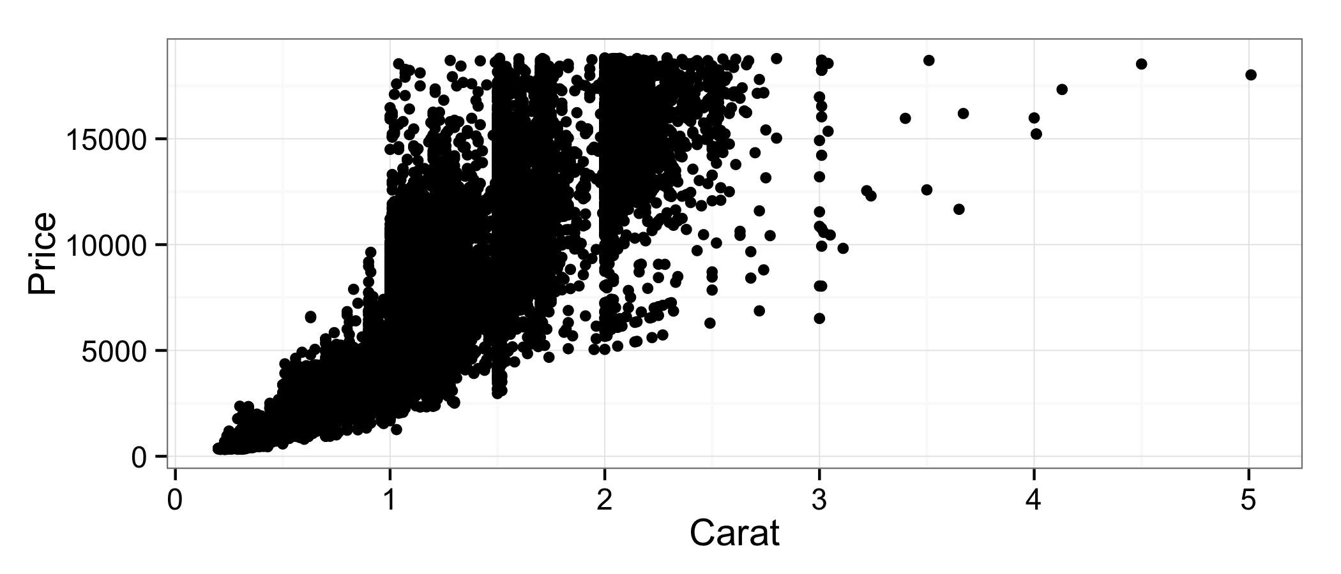

Figure 11. The 2d scatterplot.

As with previous scatterplots, however, significant overplotting swamps the graphic. While the general trend seems to hold–bigger implies pricier–it is unclear how pronounced that relationship really is, since the graphic is predominantly ink.

The standard tricks can help to some extent. When jittering in two dimensions, each point is moved randomly in a rectangle tailored to the granularity of the data in both dimensions, the smallest distance between any two points in that dimension. Since the resolution of the diamonds dataset is very high (distances are very small), jittering is not very helpful. Alpha blending and shrinking, on the other hand, help us understand things a little bit better, see Figure 12.

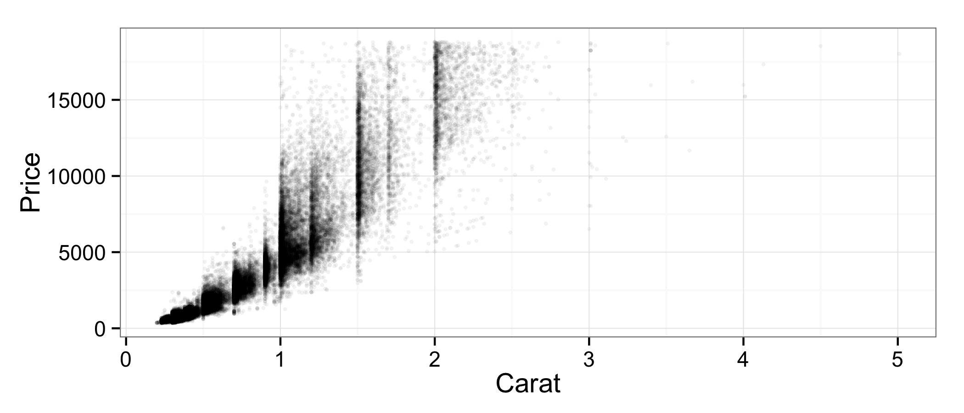Figure 12 is clearly better than Figure 11; however, the overplotting still persists, much like with Figure 8. Don’t be thrown off by less ink–Figure 12 still exhibits significant overplotting and, like with Figure 8, more isolated points are practically invisible.

Figure . The 2d scatterplot with resizing and alpha blending (opaque = 20 points).

**4.1.2 2d Histograms.** As in one dimension, the real solution is to create localized summaries–in this case, to bin. In two dimensions, the most natural way to bin is to break the *x-* and *y*-axes into intervals, the products of which create bins, and the *z*-axis is used for frequency. The name here can be somewhat confusing: the 2d histogram is a 3d graphic, but this should not be surprising. The 1d histogram is a 2d graphic because the calculated statistic (frequency) takes up the second dimension.

2d histograms look like cityscapes. An example using carat and price is in Figure 13.



Figure 13. The 2d histogram for carat and price.

The chief problem with three-dimensional 2d histograms is that, like all 3d graphics, they can present perspectival problems. For instance, more frequent bins eclipse part of the data in Figure 13: it is unclear how common small expensive diamonds are without rotating the graphic.

The remedy in such situations is to use other visual cues to communicate the frequency variable. This can be very easily motivated: if we consider the 2d histogram from directly above, we see an array of rectangles (bins) whose height is difficult to see because they are “coming out” toward us. Instead of representing frequency with height, it is better to render a 2d histogram as a 2d array of shaded rectangles with a legend indicating the correspondence between the shadings and the frequency (such correspondences are sometimes called aesthetic mappings, see Wickham 2009). An illustration of this process is presented in Figure 14; bins containing no observations are omitted.

Figure 14. The three-dimensional 2d histogram from above (left), and the more commonly used two-dimensional 2d histogram (right).



Several aspects of the histogram can be changed to try to improve visibility, for example color scales, the number of bins, and even the shape of the bins. Figure 15 shows a re-envisioning of Figure 14 using smaller, hexagonal bins with a different color scheme.

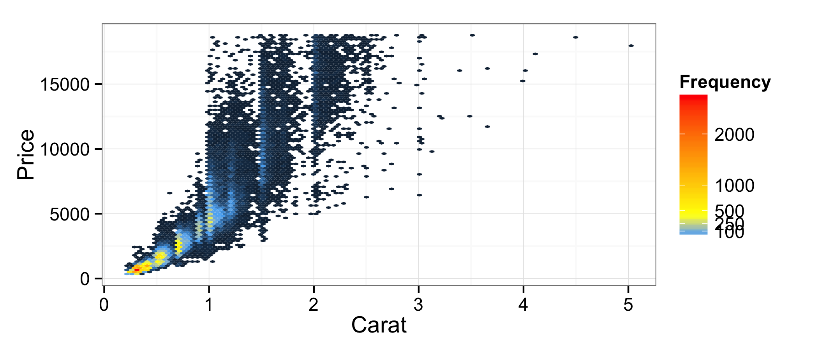

Figure . A re-envisioning of the 2d histogram in Figure 14.

The two-dimensional 2d histogram is very commonly seen in practice. In it we see that the vast majority of diamonds are very small and that the trend is clearly super-linear: as diamonds get larger, not only do their prices increase, but it they increase at an increasing rate. This can be confirmed visually using a smoother, like the one in Figure 16. Describing how these smoothers are made is beyond the scope of this article and most introductory courses, but most modern statistics graphics programs such as JMP’s Graph Builder and R’s **ggplot2** can create them with the click of a button or short line of code.

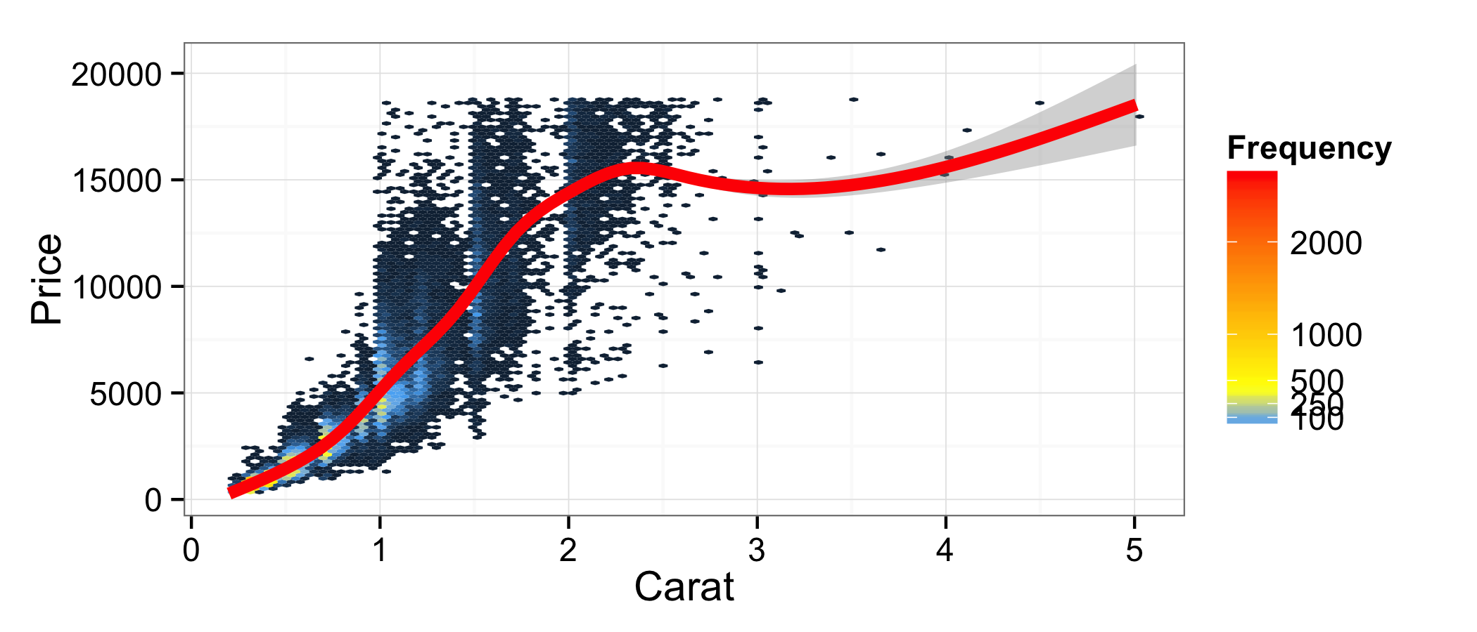

Figure . The 2d histogram in Figure 15 with a smoother overlay.

**4.1.3 Contour plots.** Kernel density estimators are also used in more than one dimension; however, seeing a 2d KDE in three dimensions is even more rare than seeing a 2d histogram in three dimensions. However, unlike the 2d histogram, there are no bins that can be colored when looking from above. Instead, the plots are made by analogy to topographical maps. The graphics are created by slicing the three-dimensional 2d KDE with flat planes at various *z* levels and projecting the intersecting curves down into the *x*-*y* plane. The result is a called a contour plot, shown in Figure 17. In general, these plots tend to be more useful than the 2d histograms.

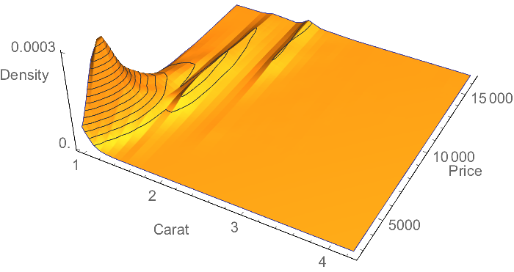

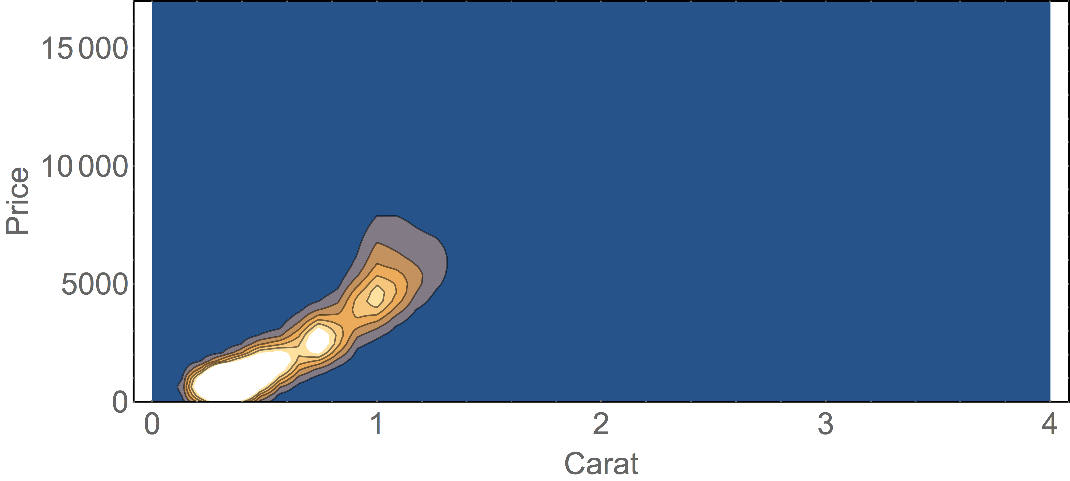

Figure . A three-dimensional 2d KDE and its associated contour plot.

**4.2 Discrete-Continuous Graphics**

At the end of Section 3.2 you may have found yourself asking, “What about boxplots?” They look at a single (typically continuous) variable, why were they not discussed?

Boxplots were not previously discussed because they are primarily used to explore interactions between a discrete variable and a continuous one. In practice, if only one continuous variable is under consideration, histograms or KDEs are generally far superior as they better communicate more of the fullness of the distribution.

*Teaching Tip: I typically teach numerical descriptives (means, standard deviations, etc.) after graphical ones. Since boxplots require percentiles (numerical descriptives), I tend to divide my discussion on graphical descriptives into two chunks: boxplots and violin plots after numerical descriptives, and everything else before.*

*Teaching Tip: Boxplots and violin plots tie in naturally with the concept of ANOVA, a common topic at the end of most introductory statistics courses, including mine. Since visualization techniques are typically taught at the beginning, reminding students of these graphics at the end can reinforce learning and give your course a coming-full-circle feel.*

Consider the relationship between clarity and price. Naturally, as a diamond’s clarity increases, we would expect its value to similarly increase. The naïve way to investigate this relationship is to use the idea of a scatterplot; this is Figure 18.

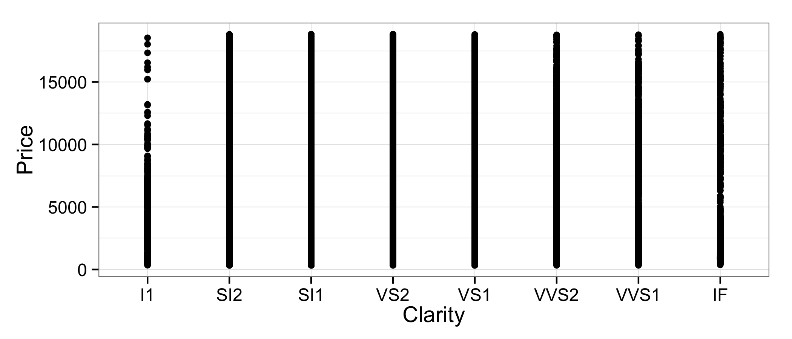

Figure . The scatterplot of price vs. clarity.

Figure 18 is a hopelessly useless graphic. With so much data, the overplotting swamps the visual display completely, so that even if there were a strong association between clarity and price, we would not be able to see it. Jittering and alpha blending can help here, too; see Figure 19.

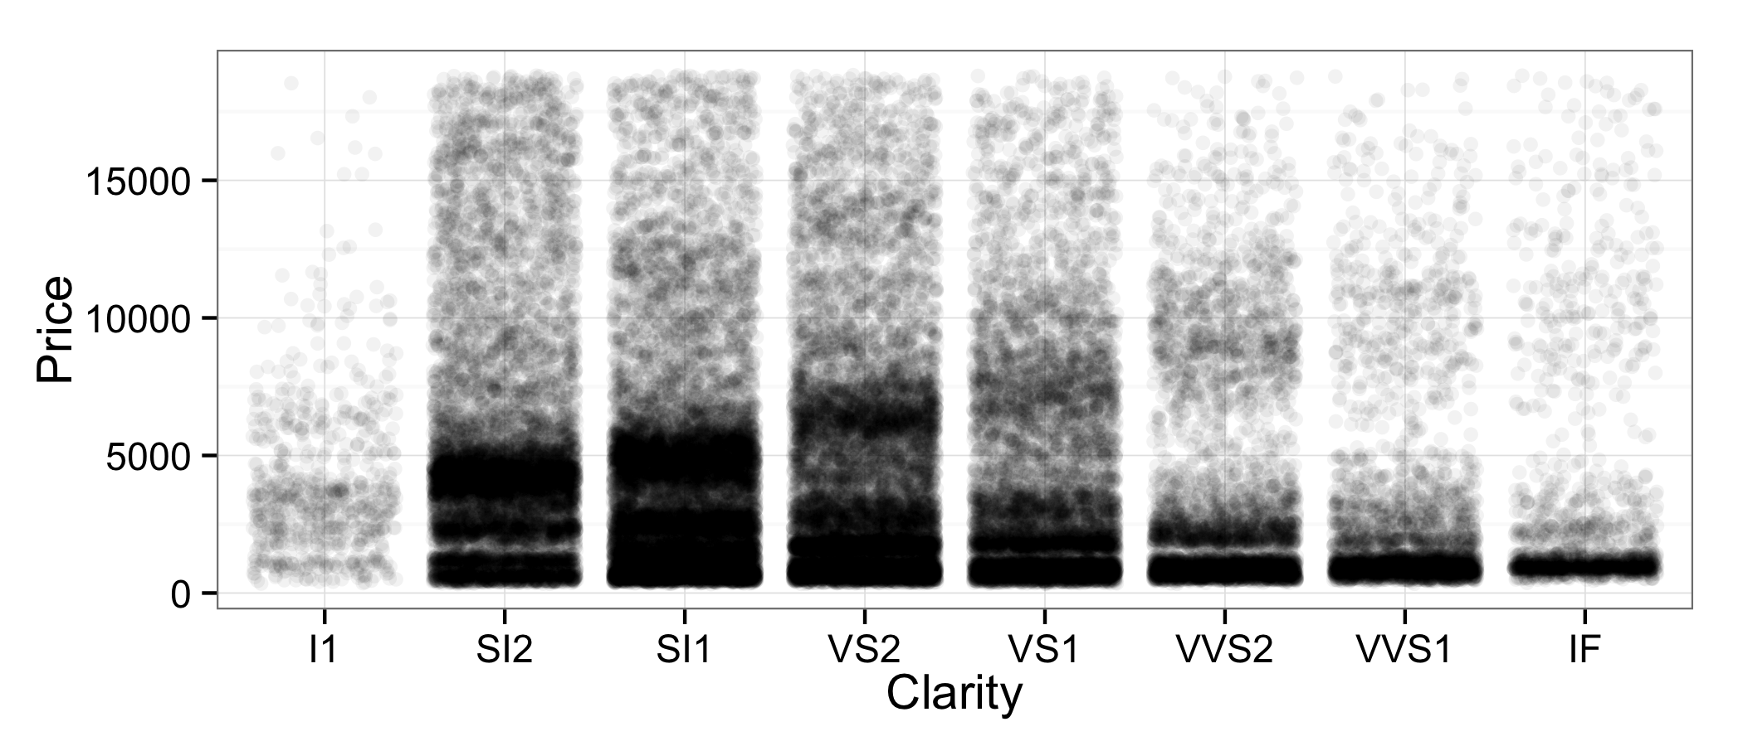

Figure . Jittered and alpha blended version of Figure 18 (opaque = 20 points).

Unfortunately, Figure 19 doesn’t resolve the problem either; overplotting is still drastic, and we can’t get any good feel for the distributions due to the extreme overplotting. Looking closer, there do appear to be clumps (mixtures) in each clarity category. While exploring these effects are outside the scope of this work, more in-depth analyses demonstrate that these can be explained by the size of the diamond and its cut.

Boxplots are a standard way to get around this kind of overplotting problem. The boxplot associated with this problem is in Figure 20. The associated violin plot, a close relative of the boxplot created by flipping over a KDE, is contained in the same figure.

The first look at Figure 20 should make you pause. Moving left to right across the ordered levels of clarity, the diamonds become *clearer*. Why, then, do they appear to cost less? Would it be correct to conclude that, as diamonds become clearer, they cost *less*? Surely something is wrong. The answer lies in the subtleties displayed in Figure 19, and we’ll see how to visualize them in Section 5. For now, we take a detour to understand the association between two other variables in the dataset, clarityand cut.





Figure . The price-clarity boxplot and violin plot.

**4.3 Discrete-Discrete Graphics**

Another interesting consideration is the relationship between clarity and cut. Since cut is, at least to some extent, at the discretion of the cutter, it would make sense that the better a diamond is in terms of clarity, the more effort the diamond cutter will put into the diamond, and consequently the better the cut of the diamond. But how are we to visualize the relationship between two discrete variables? There are only 8×5 = 40 possible combinations of clarity and cut!

One place that we may think to start is with a scatter plot. As already observed, there will be extreme overplotting between the two, so we start with jittering, alpha blending, and resizing to produce Figure 21.

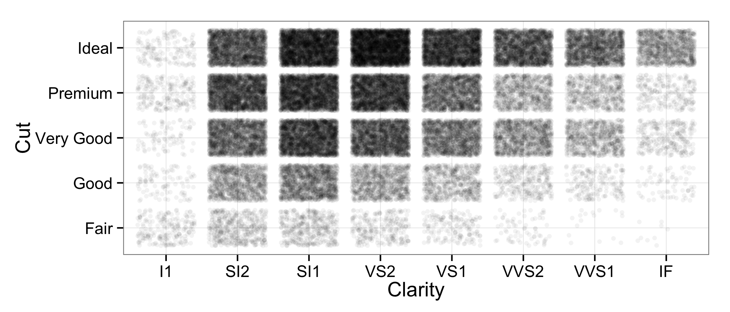

Figure . The cut-clarity scatterplot, jittered and alpha blended (20 = opaque).

While Figure 21 *looks* interesting, and does in fact tell us *something* about the joint distribution of the two variables, it doesn’t clearly clue us in to what we want to know: does clarity have an effect on cut? To answer this question, we really need some more ideas.

Consider Internally Flawless (IF) diamonds in Figure 21. By far the darkest rectangle is comprised of ideal cut diamonds, and that seems to resonate with our expectations: better diamonds, better cuts. However, notice that the interpretation is in terms of shades of black *relative to other rectangles in that column*. That is to say, the interesting thing to consider is *the proportion of IF diamonds* that are Fair, Good, Very Good, Premium and Ideal, and how that proportion change across categories. We want to understand the conditional distributions of the diamonds’ cuts, given their clarity. How can we visualize those distributions?

One idea is to try colored bar charts. Figure 22 presents two such attempts encountered frequently in practice: the dodged and stacked bar charts.

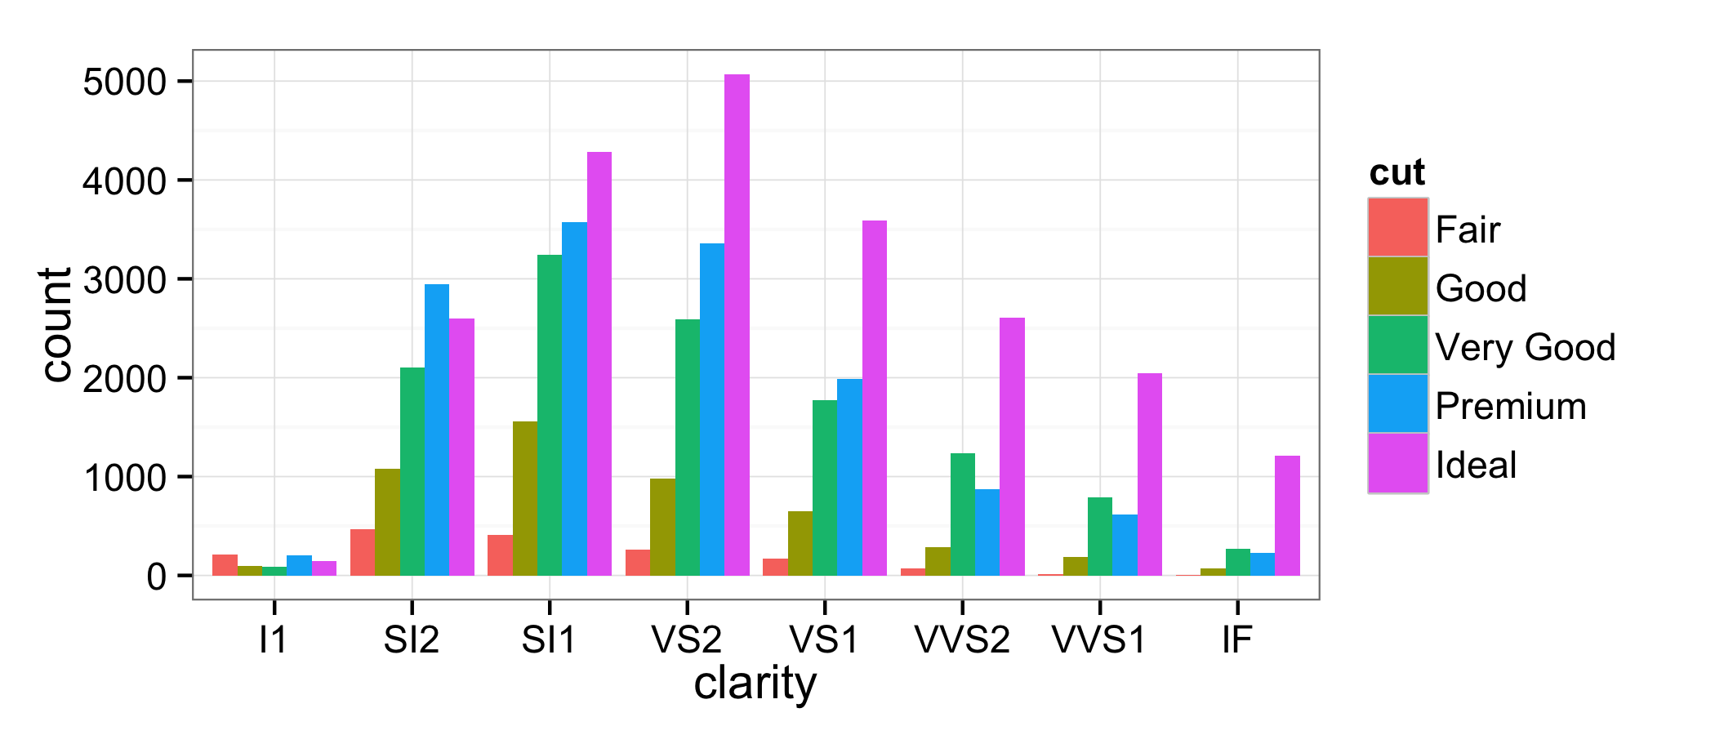

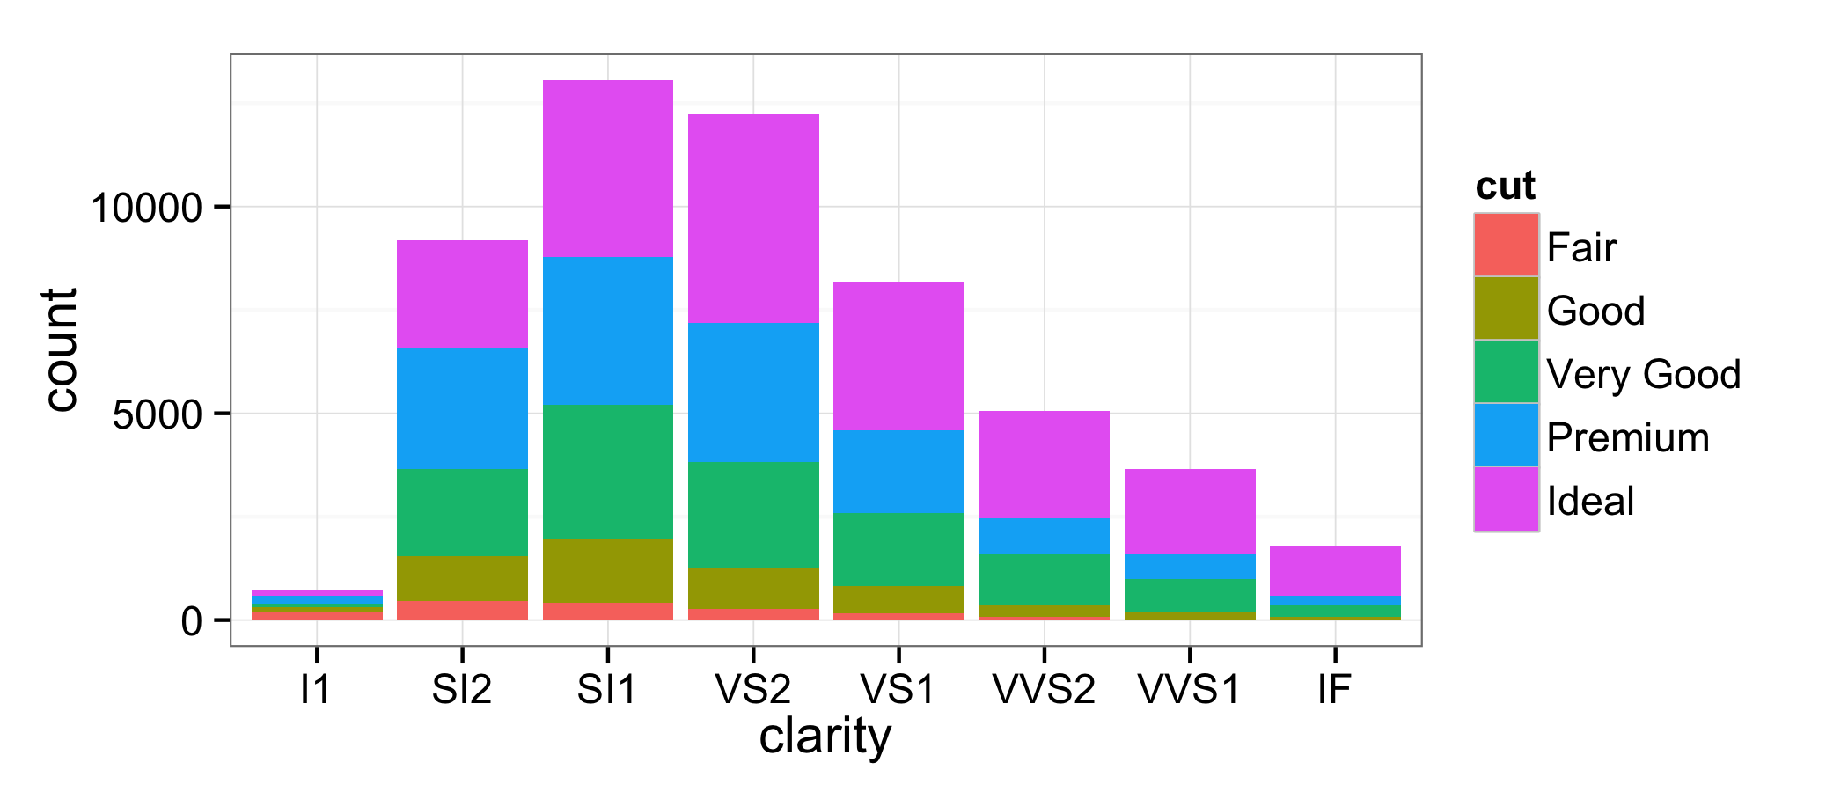

Figure . Dodged (top) and stacked (bottom) bar charts of clarity by cut.

Graphics like those in Figure 22 can be very insightful. I find them helpful in different ways: the dodged bar chart is a little better at communicating within-groups variability, and the stacked bar chart is a little better at communicating between-groups variability (e.g. most diamonds are SI1). Using either, however, it is difficult to comment on within-groups proportions across groups. For example: given a VS2 and a VS1 diamond, which is more likely to have an Ideal cut? Stacked bar charts rescaled to show relative frequency communicate this idea quite well; see Figure 23.

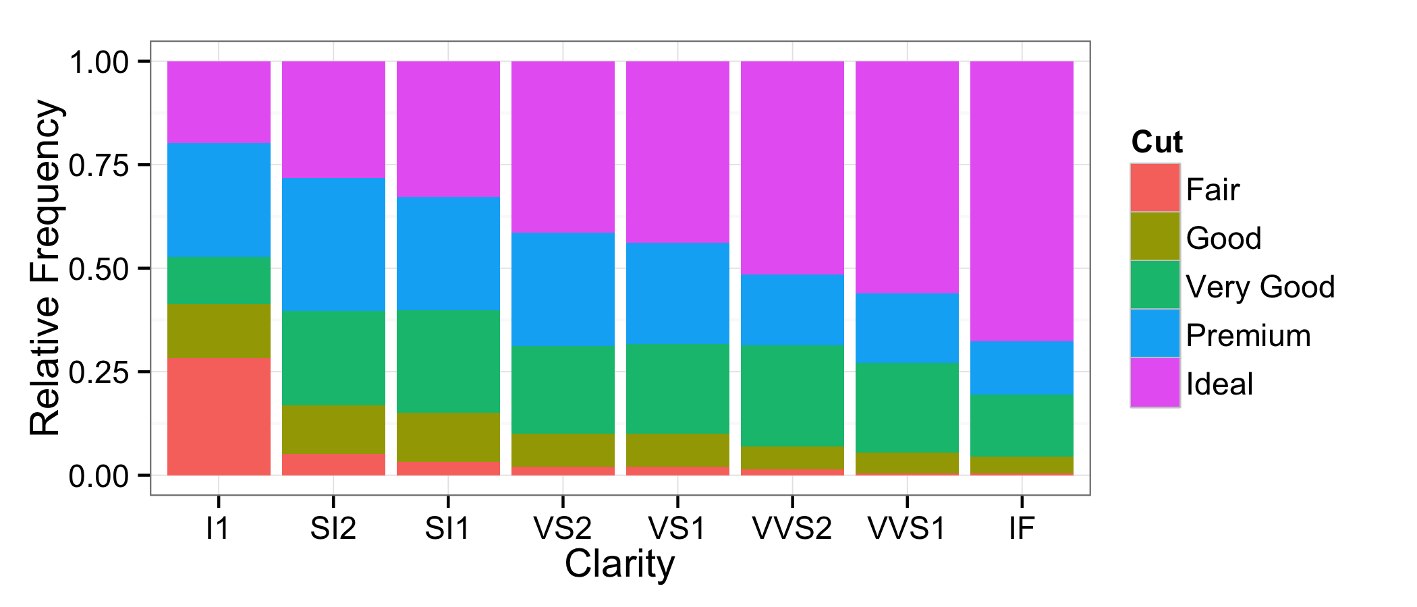

Figure . Stacked bar chart based on within-group relative frequency.

The amended stacked bar chart in Figure 23 allows us to see the effect we suspect with ease: the clearer the diamond, the better the cut. A reasonable interpretation would be that the cutter makes a better effort on these diamonds, and thus they are more likely to be cut well; however, we this is just one possible explanation. The story fits the graphics and is plausible, but the data can’t explain the why.

The drawback to the kind of graphic in Figure 23, however, is that it completely obscures between-group variability. There is no way to tell, for example, whether SI1 diamonds are more prevalent or IF diamonds are more prevalent. This problem is overcome with the mosaic plot. Mosaic plots exploit the fact that the widths of the bars in Figure 23 do not communicate meaning by scaling them by their prevalence in the overall dataset. The mosaic plot corresponding to Figure 23 is presented in Figure 24.

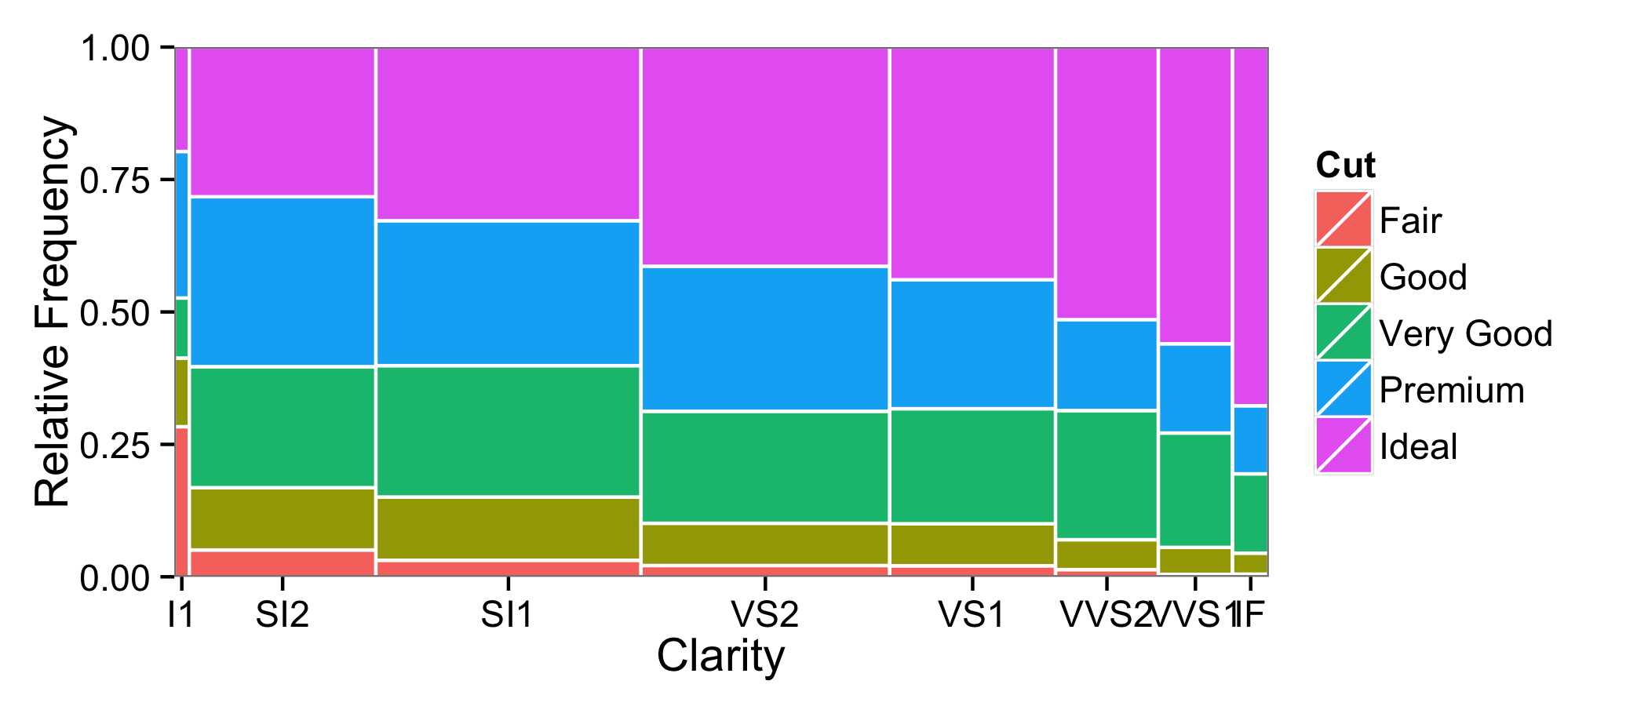

Figure . Mosaic plot of clarity by cut.

Mosaic plots present the best of both worlds: one can easily visualize within-groups variability and between-groups variability. The trend of increasing clarity, increasing cut is clearly displayed, as expected. Mosaic plots have another really nice interpretation: the area covered by each tile relative to the entire plot represents the proportion of those kinds of diamonds among the entire collection of diamonds, since joint relative frequencies (and probabilities) are products of conditional and marginal relative frequencies.

Mosaic plots are *the* go-to graphic for visualizing associations between two (or more) discrete variables (Friendly 2000). Since discrete data, particularly categorical and ordinal data, are often represented as contingency tables, they are typically thought of as visualization techniques for contingency tables (along with visualizations like multiple correspondence analysis, see Greenacre 1993). In more sophisticated treatments of categorical data analysis, they are found to be especially helpful for visually assessing the performance of log-linear models.

**6. Conclusions**

Statistical graphics obviously merit discussion in the introductory course: they are encountered in virtually every aspect of daily life and they precede any inferential analysis. However, teaching data visualization also presents several challenges: what to teach, when to teach it, and how to teach it.

In this article I’ve given my answers to these questions. On the subject of what to teach, I submit the visualization of distributions in interesting datasets, both marginal and joint; I illustrate the approach on Wickham’s diamonds. On when to teach it, I suggest the beginning of the course: the mathematics required are minimal, students typically have already been exposed to basic graphics such as pie charts, and many of the later topics can be motivated through considerations based on graphics.

How to teach it is a more complicated

**7. Acknowledgements**

It is my pleasure to thank Drs. Hadley Wickham, who created this dataset and from whom I learned many of these concepts myself several years ago, and Garrett Grolemund, with whom I’ve enjoyed many conversations about similar topics. I have undoubtedly benefited from their considerations of the diamonds dataset.

**References**

Aliaga, M., Cobb, G., Cuff, C., Garfield, J., Gould, R., Lock, R., Moore, T., Rossman, A., Stephenson, B., Utts, J., Velleman, P., and Witmer, J. (2005), *Guidelines for assessment and instruction in statistics education: College report*. The American Statistical Association. Available at <http://www.amstat.org/education/gaise/>.

Greenacre, M. (1993), *Correspondence Analysis in Practice*, London, Academic Press.

Friendly, M. (2000), *Visualizing Categorical Data*, SAS Institute.

Heymann, S. and Le Grande, B. (2013), “Graph Viz 101: Perceptual support of visualization.” Available at <http://linkurio.us/graph-viz-101-perceptual-support-of-visualization/>.

Kahle, D. (2014), “Animating Statistics: A New Kind of Applet for Exploring Probability Distributions,” *Journal of Statistics Education*, 22(2), 1–21.

Pruim, R., Horton, N., and Kaplan, D. (2014), *Start Teaching with R,* Preliminary Edition (Draft). Available at

<http://cran.r-project.org/web/packages/mosaic/vignettes/V2StartTeaching.pdf>.

Scott, D. (1992), *Multivariate Density Estimation: Theory, Practice, and Visualization*, New York, NY: John Wiley & Sons, Inc.

Tukey, J. (1961), The Future of Data Analysis, *The Annals of Mathematical Statistics*, 1–67.

Tukey, J. (1977), *Exploratory Data Analysis*, Boston, MA: Pearson.

Tufte, E. (2001), *The Visual Display of Quantitative Information*, 2nd Edition, Cheshire, CT, Graphics Press.

Wickham, H. (2009), *ggplot2: Elegant Graphics for Data Analysis*, New York, NY: Springer.

Wickham, H. (2013), “Bin-summarise-smooth: A framework for visualising large data.” Technical report. Available at <http://vita.had.co.nz/papers/bigvis.pdf>.

David J. Kahle, Ph.D.

Assistant Professor of Statistical Science

Department of Statistical Science

Baylor University

One Bear Place #97140

Waco, Texas, USA 76798

(254) 710-6102

[david_kahle@baylor.edu](mailto:david_kahle@baylor.edu)

1. While the difference is in fact significant (*p* < .01) and seems plausible, if one digs deeper into this phenomenon, he will find that the difference is not quite as pronounced, and perhaps not even as certain, as it may appear on the surface. I disregard these possibilities, however, as they don’t really matter and detract from the moral of the story.
2. Students typically have not gotten to the normal distribution at this point in the course, so the “bell curve” vernacular can be helpful.